**LAB13**

**Jimmy Palma**

**610756**

1. **Carry out the steps of Dijkstra's algorithm to compute the length of the shortest path between vertex V and vertex Y in the graph below. Your final answer should consist of three elements:** 
   1. **The length of the shortest path from V to Y**

3

* 1. **The list A[] which shows shortest distances between V and every other vertex**

A = [V = 0, U = 1, X = 2, W = 3, Y = 3]

* 1. **The list B[] which shows shortest paths between V and every other vertex**

B = [V = ∲, U = (V, U), X = (V, X), W = (V, W), Y = (V, U) (U, Y)]

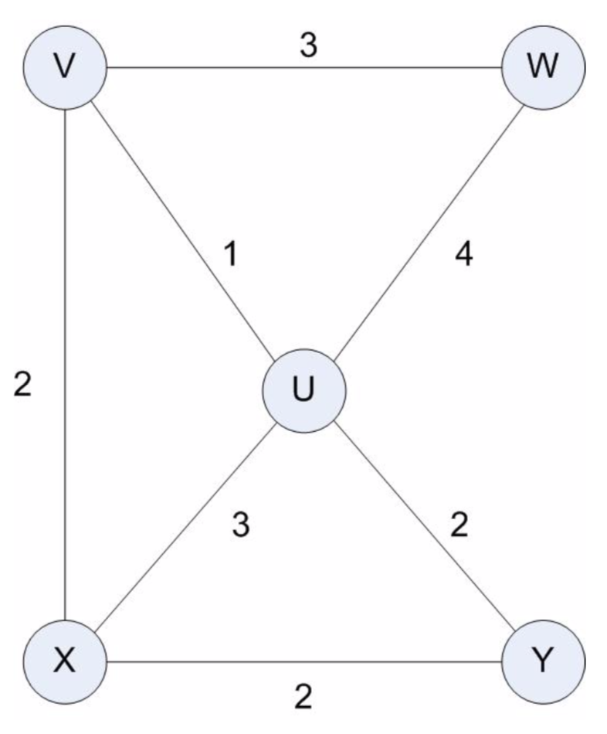

A[V] = 0; B[v] = ∲

Add V to X

Pool = {(V, W) (V, U) (V, X)}

(V, W) = A[V] + wt(V, W) = 0 + 3 = 3

(V, U) = A[V] + wt(V, U) = 0 + 1 = 1 ←

(V, X) = A[V] + wt(V, X) = 0 + 2 = 2

A[U] = 1 B[U] = ∲ + (V, U)

Add U to X

Pool = {(V, X) (V, W) (U, W) (U, Y) (U, X)}

(V, X) = A[V] + wt(V, X) = 0 + 2 = 2 ←

(V, W) = A[V] + wt(V, W) = 0 + 3 = 3

(U, W) = A[U] + wt(U, W) = 1 + 4 = 5

(U, Y) = A[U] + wt(U, Y) = 1 + 2 = 3

(U, X) = A[U] + wt(U, X) = 1 + 3 = 4

A[X] = 2, B[X] = B[V] + (V, X) => (V, X)

Add X TO X

POOL = {(V, W) (U, W) (X, Y) (U, Y)}

(V, W) = A[V] + wt(V, W) = 0 + 3 = 3 ←

(U, W) = A[U] + wt(U, W) = 1 + 4 = 5

(X, Y) = A[X] + wt(X, Y) = 2 + 2 = 4

(U, Y) = A[U] + wt(U, Y) = 1 + 2 = 3

A[W] = 3 B[W] = B[V] + (V, W) = (V, W)

Add W to X

Pool = {(X, Y) (U, Y}

(X, Y) = A[X] + wt(X, Y) = 2 + 2 = 4

(U, Y) = A[U] + wt(U, Y) = 1 + 2 = 3 ←

A[Y] = 3, B[Y] = B[U] + (U, Y) = (V, U) (U, Y)

A = [V = 0, U = 1, X = 2, W = 3, Y = 3]

B = [V = ∲, U = (V, U), X = (V, X), W = (V, W), Y = (V, U) (U, Y)]

1. **Points about Dijkstra’s Algorithm**

**a. What is the shortest path from A to C in the graph below?**

b.

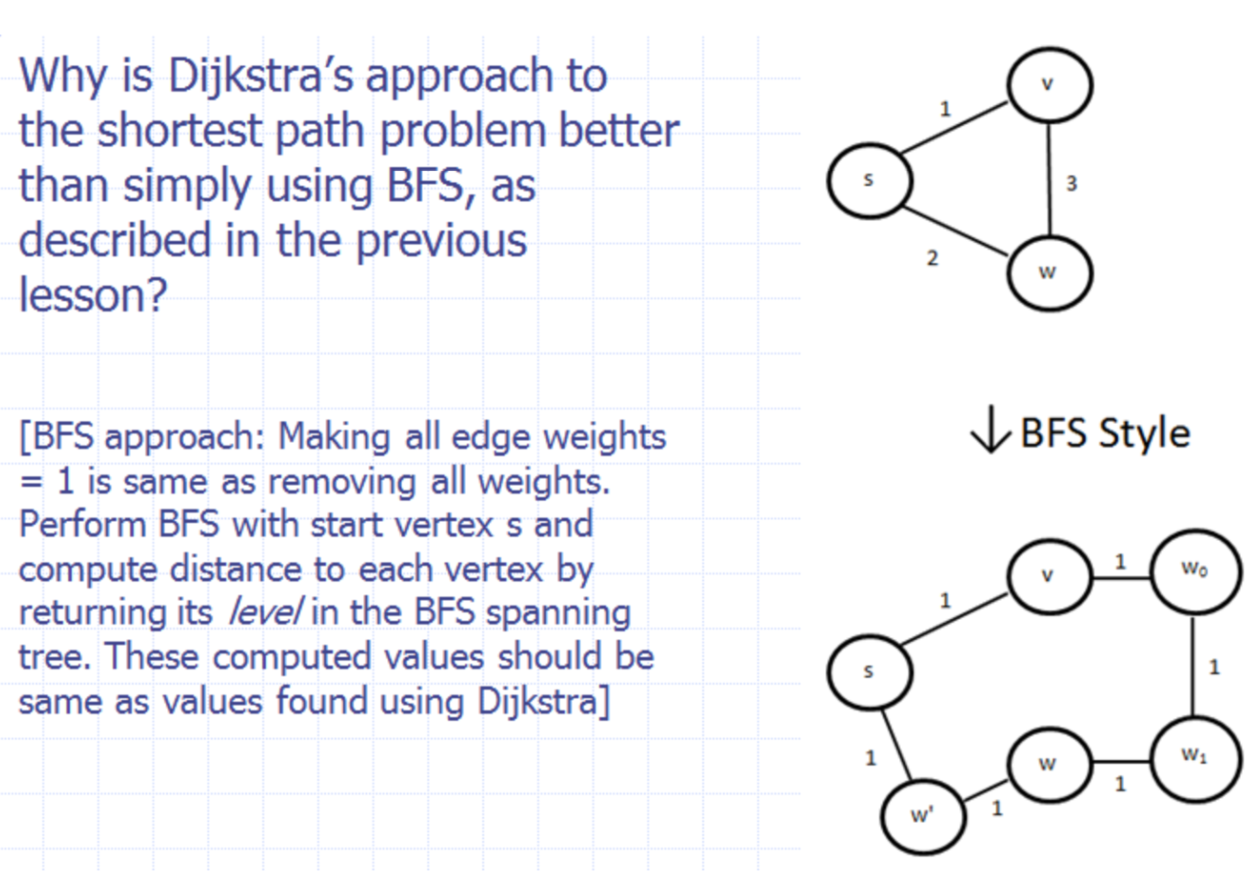

The Dijkstra guarantee to find the sortest path, but BFS only show a path between the vertex that is not guarantee it is the shortest

Dijkstra is O(nlogn)

Bfs = O(sum of edge weigth + n + m) = Ω(nˆ2)

1. **Describe an algorithm for deleting a key from a heap-based priority queue that runs in O(log n) time, where n is the number of nodes. (Hint: You may use auxiliary storage as the priority queue is built and maintained. Assume there are no two nodes have the same key.) This technique is needed for the optimized Dijkstra algorithm discussed in the slides.**

A[S] <- 0

A[V] <- INFINITY

Q <- new heap based priority queue

H <- HashMap

H <- fillHash //key of hash map is the key of priorityqueue and the value the node

Q.removeMin();

H.removeKeyEliminated

1. **Carry out the steps of Kruskal’s algorithm for the following weighted graph, using the tree-based DisjointSets data structure to represent clusters. Keep track of edges as they are added to T and show the state of representing trees through each iteration of the main while loop**

